**PONDICHERRY UNIVERSITY**

**(A Central university)**



**SCHOOL OF ENGINEERING AND TECHNOLOGY**

**DEPARTMENT OF COMPUTER SCIENCE**

**M.Sc. Computer Science**

|  |  |  |
| --- | --- | --- |
| **NAME** | **:** | **ELITAM. SHIRISHA** |
| **REG.NO** | **:** | **23370019** |
| **SEMESTER** | **:** | **III** |
| **SUBJECT** | **:** | **ADVANCE COMPUTER NETWORKS & WEB TECHNOLOGY** |
| **SUBJECT CODE** | **:** | **CSSC-513** |

**PONDICHERRY UNIVERSITY**

**(A Central university)**



**SCHOOL OF ENGINEERING AND TECHNOLOGY**

**DEPARTMENT OF COMPUTER SCIENCE**

**M.Sc. Computer Science**

PRACTICAL LAB RECORD

**BONAFIDE CERTIFICATE**

This is to certify that this is a Bonafide record of practical work done by **ELITAM SHIRISHA**, having Reg. No. **23370019** semester - III from the month July 2024 to November 2024.

**FACULTY IN-CHARGE** SUBMITTED FOR THE PRACTICAL EXAM HELD ON: ______________

**INTERNAL EXAMINER** **EXTERNAL EXAMINER**

INDEX

|  |  |  |  |  |  |  |  |  |  |
| --- | --- | --- | --- | --- | --- | --- | --- | --- | --- |
| EX.  No | | DATE | | TITLE | | PAGE | | SIGNATURE | |
| 1 | |  | | Home Page | | 1-5 | |  | |
| 2 | |  | | Login Page | | 5-10 | |  | |
| 3 | |  | | Registration Page | | 11-16 | |  | |
| 4 | |  | | Catalogue Page | | 17-24 | |  | |
| 5 | |  | | Cart Page | | 24-29 | |  | |
| 6 | |  | | Network Topology   * Star Topology * Bus Topology | | 30-31 | |  | |
| 7 | |  | | VLAN Configuration | | 32 | |  | |
| 8 | |  | | Firewall | | 33 | |  | |
| 9 | |  | | Routers Configuration | | 34 | |  | |
|  | |  | |  | |  | |  | |
|  | |  | |  | |  | |  | |

# HOME PAGE

<!DOCTYPE html>

<html lang="en">

<head>

<meta charset="UTF-8">

<meta name="viewport" content="width=device-width, initial-scale=1.0">

<title>Online Book Store</title>

<link rel="stylesheet" href="style.css">

</head>

<body>

<div class="header">

<div class="logo">

<img src="<header>

<div class="logo">

<img src="C:\Users\BABITHA\Downloads\bookstore2.png" alt="Book Store Logo" class="logo-img">

Online Book Store

</div>

<div class="nav">

<a href="home.html"><b>Home</b></a>

<a href="login3.html"><b>Login</b></a>

<a href="registration.html"><b>Registration</b></a>

<a href="cat2.html"><b>Catalogue</b></a>

<a href="cart2.html"><b>Cart</b></a>

</div>

</div>

<div class="container">

<div class="left-frame">

<h3>Categories</h3>

<ul>

<li><a href="cse.html?category=CSE">CSE</a></li>

<li><a href="ece.html?category=ECE">ECE</a></li>

<li><a href="eee.html?category=EEE">EEE</a></li>

<li><a href="civil.html?category=CIVIL">CIVIL</a></li>

</ul>

</div>

<div class="right-frame">

<p><h2>Welcome to the Online Book Store. Browse through our catalogue and find the books you love!</h2></p>

</div>

</div>

</body>

</html>

body {

font-family: Arial, sans-serif;

}

.header {

display: flex;

justify-content: space-between;

align-items: center;

background-color: #8b0a50;

padding: 10px;

}

.logo-img {

width: 100px; /* Adjust size as needed */

height: auto;

vertical-align: middle;

margin-right: 40px; /* Adds space between the image and the text */

}

.logo {

font-size: 24px;

font-weight: bold;

}

.site-name {

font-size: 30px;

color: #f4f4f4;

}

.nav a {

margin: 0 20px;

text-decoration: none;

color: #121212;

}

.container {

display: flex;

margin-top: 20px;

}

.left-frame {

font-size: 25px;

width: 20%;

background-color:#bebebe ;

padding: 10px;

}

.right-frame {

width: 75%;

padding: 20px;

}

h3 {

margin-top: 0;

}

**OUTPUT:**

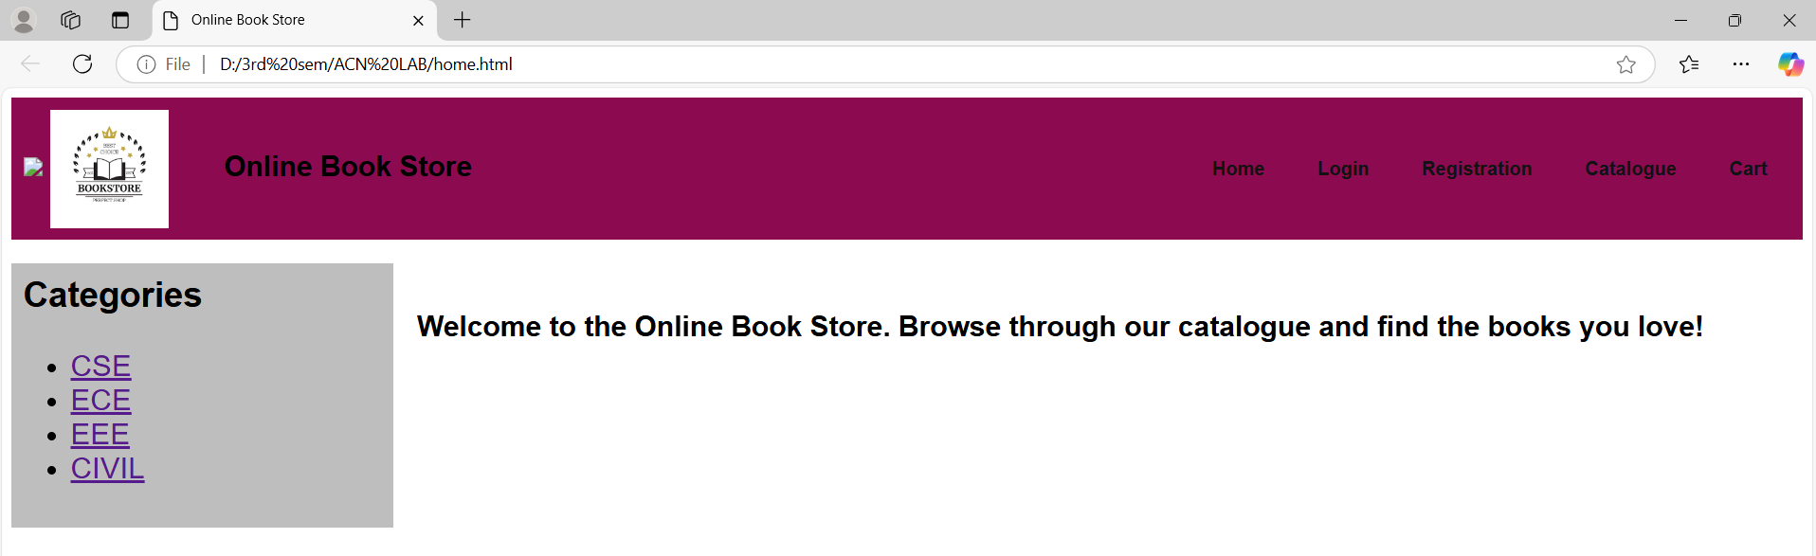

**LOGIN PAGE**

<!DOCTYPE html>

<html lang="en">

<head>

<meta charset="UTF-8">

<meta name="viewport" content="width=device-width, initial-scale=1.0">

<title>Login - Online Book Store</title>

<link rel="stylesheet" href="stylereg.css">

</head>

<body>

<div class="header">

<div class="logo">

<img src="C:\Users\BABITHA\Downloads\bookstore2.png" alt="Book Store Logo" class="logo-img">

Online Book Store

</div>

<div class="nav">

<a href="home.html"><b>Home</b></a>

<a href="login.html"><b>Login</b></a>

<a href="register.html"><b>Registration</b></a>

<a href="cat2.html"><b>Catalogue</b></a>

<a href="cart2.html"><b>Cart</b></a>

</div>

</div>

<div class="container">

<div class="login-form">

<h2>Login</h2>

<form action="home.html" method="POST">

<div class="input-group">

<label for="username">Username:</label>

<input type="text" id="username" name="username" required>

</div>

<div class="input-group">

<label for="password">Password:</label>

<input type="password" id="password" name="password" required>

</div>

<button type="submit">Login</button>

<p class="message">Not registered? <a href="register.html">Create an account</a></p>

</form>

</div>

</div>

</body>

</html>

body {

font-family: Arial, sans-serif;

background-color: #f4f4f4;

margin: 0;

padding: 0;

}

.header {

display: flex;

justify-content: space-between;

align-items: center;

padding: 10px 20px;

background-color: #8b0a50;

color: white;

}

.logo {

display: flex;

align-items: center;

}

.logo-img {

height: 80px; /* Adjust height as necessary */

margin-right: 40px;

}

.nav a {

color: white;

text-decoration: none;

margin: 0 15px;

font-weight: bold;

}

.container {

display: flex;

justify-content: center;

align-items: center;

flex-direction: column;

padding: 40px 20px;

}

.login-form, .registration-form {

background-color: white;

padding: 20px;

border-radius: 8px;

box-shadow: 0 2px 10px rgba(0, 0, 0, 0.1);

width: 100%;

max-width: 400px;

}

h2 {

text-align: center;

margin-bottom: 20px;

}

.input-group {

margin-bottom: 15px;

text-align: left;

}

.input-group label {

display: block;

margin-bottom: 5px;

}

.input-group input {

width: 100%;

padding: 10px;

border: 1px solid #ccc;

border-radius: 4px;

}

button {

width: 100%;

padding: 10px;

background-color: #8b0a50;

color: white;

border: none;

border-radius: 4px;

cursor: pointer;

}

button:hover {

background-color: #454d55;

}

.message {

margin-top: 15px;

font-size: 14px;

text-align: center;

}

**OUTPUT:**

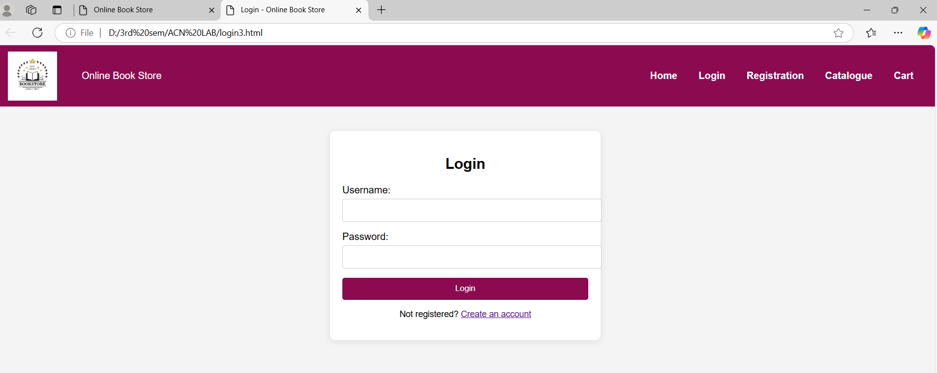

**REGISTRATION PAGE**

<html>

<head>

<title> Registration Page </title>

<link rel="stylesheet" href="style.css">

</head>

<body>

<center>

<h3 align="center"><u>REGISTRATION PAGE</u></h3>

<table border="3">

<tr><td>

<from style="background-color:white

;font-family:verdana">

<table cellspacing="10" cellpadding="5">

<tr><td>NAME</td><td><input type="text" size="30" name="username" required></td></tr>

<tr><td>PASSWORD</td><td><input type="password" size="30" name="password" required></td></tr>

<tr><td>E-MAIL ID</td><td><input type="text" size="30" name="email" required></td></tr>

<tr><td>PHONE</td><td><input type="text" size="30" name="phone" required></td></tr>

<tr><td>GENDER</td><td><input type="radio" name="gen" value="m" />MALE <input type="radio" name="gen" value="f" />FEMALE </td></tr>

<tr>

<td>

<label for="birthday">DATE OF BIRTH</label>

</td>

</tr>

<td><select name="day">

<option value="day">DAY</option>

<option value="1">1</option>

<option value="2">2</option>

<option value="3">3</option>

<option value="4">4</option>

<option value="5">5</option>

<option value="6">6</option>

<option value="7">7</option>

<option value="8">8</option>

<option value="9">9</option>

<option value="10">10</option>

<option value="11">11</option>

<option value="12">12</option>

<option value="13">13</option>

<option value="14">14</option>

<option value="15">15</option>

<option value="16">16</option>

<option value="17">17</option>

<option value="18">18</option>

<option value="19">19</option>

<option value="20">20</option>

<option value="21">21</option>

<option value="22">22</option>

<option value="23">23</option>

<option value="24">24</option>

<option value="25">25</option>

<option value="26">26</option>

<option value="27">27</option>

<option value="28">28</option>

<option value="29">29</option>

<option value="30">30</option>

<option value="31">31</option>

</select>

<select name="month">

<option value="month">MONTH</option>

<option value="jan">JANUARY</option>

<option value="feb">FEBRUARY</option>

<option value="mar">MARCH</option>

<option value="apr">APRIL</option>

<option value="may">MAY</option>

<option value="jun">JUNE</option>

<option value="jul">JULY</option>

<option value="aug">AUGUST</option>

<option value="sep">SEPTEMBER</option>

<option value="oct">OCTOBER</option>

<option value="nov">NOVEMBER</option>

<option value="dec">DECEMBER</option>

</select>

<select name="year">

<option value="year">YEAR</option>

<option value="1986">1986</option>

<option value="1987">1987</option>

<option value="1988">1988</option>

<option value="1989">1989</option>

<option value="1990">1990</option>

<option value="1991">1991</option>

<option value="1992">1992</option>

<option value="1993">1993</option>

<option value="1994">1994</option>

<option value="1995">1995</option>

<option value="1996">1996</option>

<option value="1997">1997</option>

<option value="1998">1998</option>

<option value="1999">1999</option>

<option value="2000">2000</option>

<option value="2001">2001</option>

<option value="2002">2002</option>

<option value="2003">2003</option>

<option value="2004">2004</option>

<option value="2005">2005</option>

<option value="2006">2006</option>

<option value="2007">2007</option>

<option value="2008">2008</option>

<option value="2009">2009</option>

<option value="2010">2010</option>

<option value="2011">2011</option>

<option value="2012">2012</option>

<option value="2013">2013</option>

<option value="2014">2014</option>

<option value="2015">2015</option>

<option value="2016">2016</option>

<option value="2017">2017</option>

<option value="2018">2018</option>

<option value="2019">2019</option>

<option value="2020">2020</option>

<option value="2021">2021</option>

<option value="2022">2022</option>

<option value="2023">2023</option>

<option value="2024">2024</option>

</select></td></tr>

<tr><td>LANGUAGES KNOWN</td>

<td>

<input type="checkbox" value="eng" name="lang" />ENGLISH

<input type="checkbox" value="tel" name="lang" />TELUGU

<input type="checkbox" value="hin" name="lang" />HINDI

<input type="checkbox" value="tam" name="lang" />TAMIL

</td></tr>

<tr>

<td>ADDRESS</td>

<td><textarea name="addr" cols="25" rows="5"></textarea></td></tr>

<tr><td colspan="2" align="center"><input type="submit" value="SUBMIT"/>

&nbsp;&nbsp;&nbsp;&nbsp;&nbsp;&nbsp;<input type="rest" value="RESET" /></td>

</tr>

</table>

</form>

</td></tr></table>

</center>

</body>

</html>

**OUTPUT:**

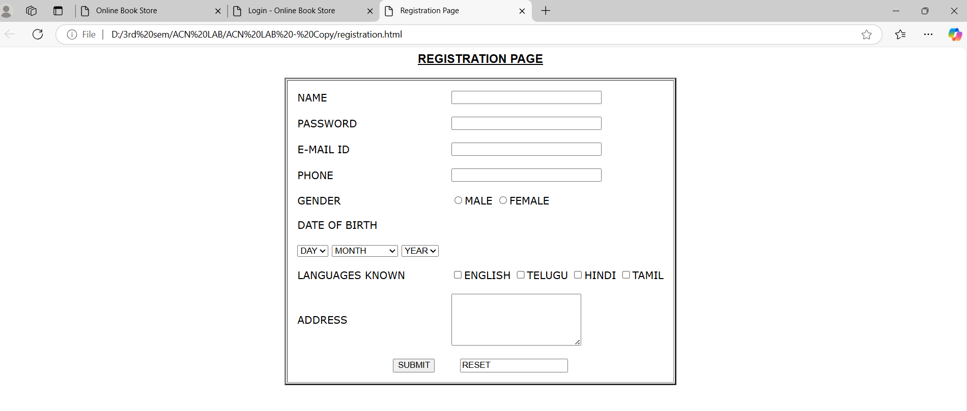

**CATALOGUE PAGE**

<!DOCTYPE html>

<html lang="en">

<head>

<meta charset="UTF-8">

<meta name="viewport" content="width=device-width, initial-scale=1.0">

<title>Catalogue Page</title>

<link rel="stylesheet" href="catalogue.css">

</head>

<body>

<header>

<div class="logo">

<img src="C:\Users\BABITHA\Downloads\bookstore2.png" alt="Book Store Logo" class="logo-img">

Online Book Store

</div>

<nav>

<a href="home.html"><b>Home</b></a>

<a href="login.html"><b>Login</b></a>

<a href="registration.html"><b>Registration</b></a>

<a href="cat2.html"><b>Catalogue</b></a>

<a href="cart2.html"><b>Cart</b></a>

</nav>

</header>

<main>

<h1>Book Catalogue</h1>

<table>

<thead>

<tr>

<th>Cover</th>

<th>Title</th>

<th>Author</th>

<th>Publisher</th>

<th>Price</th>

<th>Action</th>

</tr>

</thead>

<tbody>

<tr>

<td><img src="C:\ACN LAB\java.jpeg" alt="Book 1" class="book-cover"></td>

<td>Java 2</td>

<td>Watson</td>

<td>BPB Publications</td>

<td>Rs 35.5</td>

<td><button onclick="addToCart('Java 2', 'Watson', 'BPB Publications', 35.5)">Add to Cart</button></td>

</tr>

<tr>

<td><img src="C:\ACN LAB\xml.jpeg" alt="Book 2" class="book-cover"></td>

<td>XML Bible</td>

<td>Winston</td>

<td>Wiley</td>

<td>Rs 40.5</td>

<td><button onclick="addToCart('XML Bible', 'Winston', 'Wiley', 40.5)">Add to Cart</button></td>

</tr>

<tr>

<td><img src="C:\Users\BABITHA\Downloads\AI 2.jpg" class="book-cover"></td>

<td>AI</td>

<td>S. Russel</td>

<td>Prentice Hall</td>

<td>Rs 63</td>

<td><button onclick="addToCart('AI', 'S. Russel', 'Prentice Hall', 63)">Add to Cart</button></td>

</tr>

<tr>

<td><img src="C:\ACN LAB\html.jpeg" alt="Book 1" class="book-cover"></td>

<td>HTML </td>

<td>Sam Peter</td>

<td>Sam Publications</td>

<td>Rs 35.5</td>

<td><button onclick="addToCart('HTML', 'Sam Peter', 'Sam Publications', 35.5)">Add to Cart</button></td>

</tr>

</tbody>

</table>

</main>

<script>

function addToCart(title, author, publisher, price) {

const cart = JSON.parse(localStorage.getItem('cart')) || [];

cart.push({ title, author, publisher, price });

localStorage.setItem('cart', JSON.stringify(cart));

alert(title + " has been added to the cart.");

window.location.href = 'cart.html'; // Redirect to the cart page

}

</script>

</body>

</html>

{

margin: 0;

padding: 0;

box-sizing: border-box;

}

body {

font-family: Arial, sans-serif;

background-color: #f4f4f4;

color: #333;

}

header {

background-color: #8b0a50;

color: white;

padding: 20px 0;

text-align: center;

}

.logo {

display: flex;

align-items: center;

justify-content: center;

margin-bottom: 10px;

}

.logo-img {

width: 50px;

height: 50px;

margin-right: 10px;

}

nav {

margin-top: 10px;

}

nav a {

color: white;

margin: 0 15px;

text-decoration: none;

font-weight: bold;

transition: color 0.3s;

}

nav a:hover {

color: #76eec6;

}

main {

max-width: 1200px;

margin: 20px auto;

padding: 20px;

background: white;

border-radius: 8px;

box-shadow: 0 2px 10px rgba(0, 0, 0, 0.1);

}

h1 {

text-align: center;

margin-bottom: 20px;

}

table {

width: 100%;

border-collapse: collapse;

}

table th, table td {

border: 1px solid #ccc;

padding: 10px;

text-align: left;

}

table th {

background-color: #35424a;

color: white;

}

.book-cover {

width: 80px; /* Set a fixed width for the book cover images */

height: auto;

}

button {

background-color: #35424a;

color: white;

border: none;

border-radius: 5px;

padding: 10px 15px;

cursor: pointer;

transition: background-color 0.3s;

}

button:hover {

background-color: #454f5b;

}

@media (max-width: 768px) {

main {

padding: 10px;

}

nav a {

display: block;

margin: 5px 0;

}

table {

font-size: 0.9em; /* Smaller font for mobile */

}

.book-cover {

width: 60px; /* Smaller book cover for mobile */

}

}

**OUTPUT:**

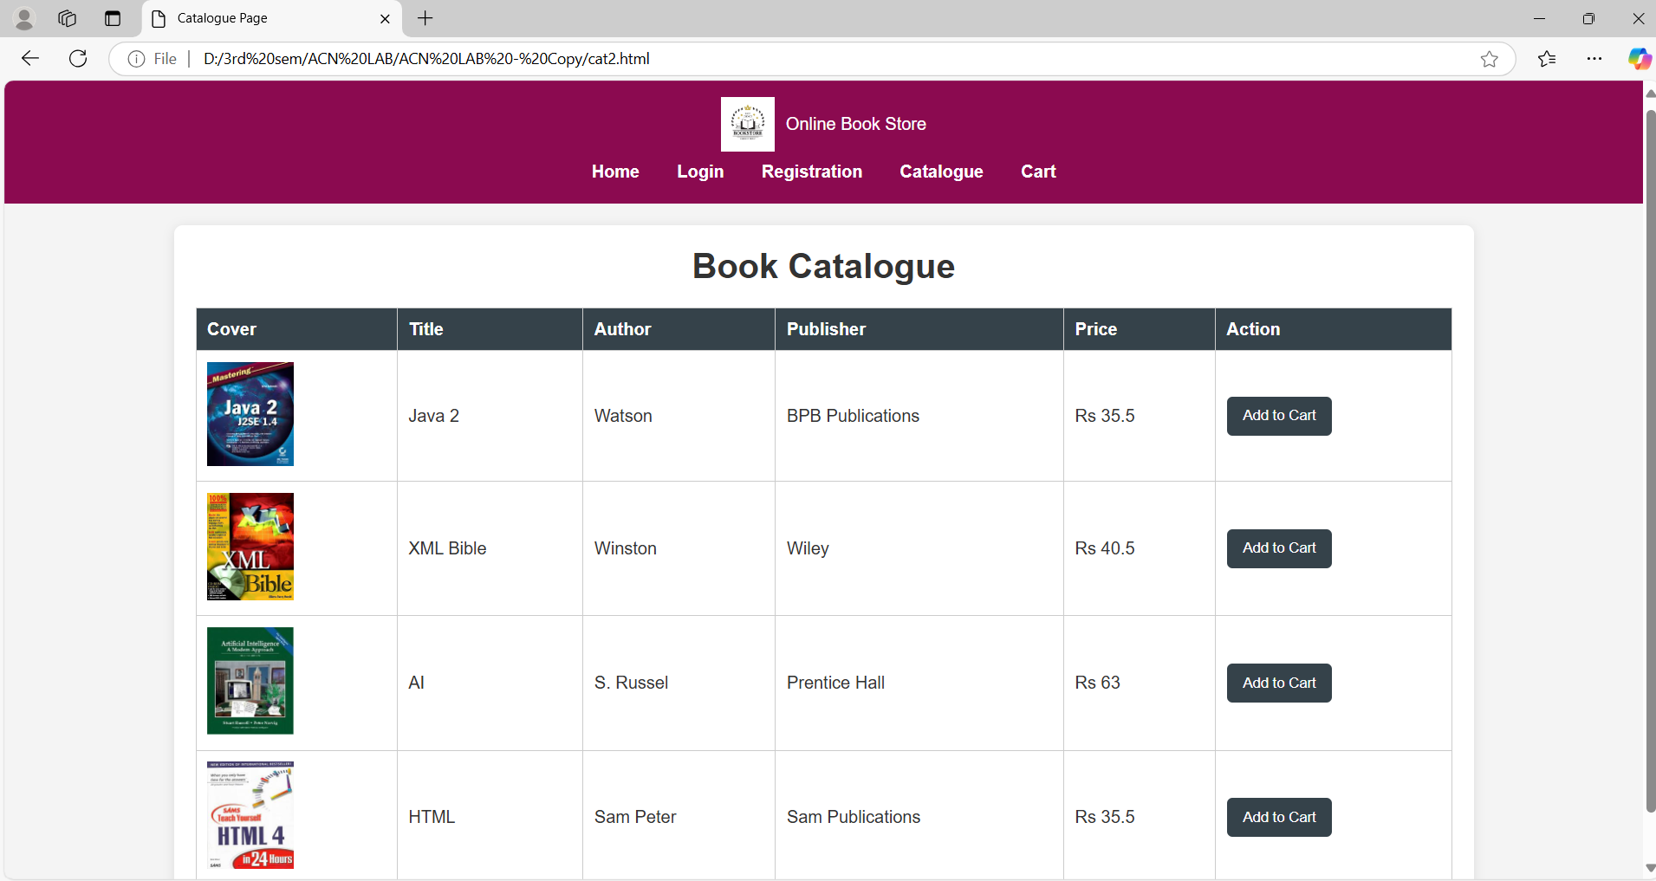

**CART PAGE**

<!DOCTYPE html>

<html lang="en">

<head>

<meta charset="UTF-8">

<meta name="viewport" content="width=device-width, initial-scale=1.0">

<title>Cart Page</title>

<link rel="stylesheet" href="cart2.css">

</head>

<body>

<header>

<div class="logo">

<img src="C:\Users\BABITHA\Downloads\bookstore2.png" alt="Book Store Logo" class="logo-img">

Online Book Store

</div>

<nav>

<a href="cat2.html">Catalogue</a>

<a href="#">Cart</a>

</nav>

</header>

<main>

<h1>Your Cart</h1>

<table>

<thead>

<tr>

<th>Title</th>

<th>Author</th>

<th>Publisher</th>

<th>Price</th>

</tr>

</thead>

<tbody id="cart-items">

<!-- Cart items will be dynamically inserted here -->

</tbody>

</table>

<div class="total">

<h3 id="total-price">Total: Rs 0.00</h3>

</div>

<button class="checkout-button">Checkout</button>

</main>

<script>

function loadCart() {

const cart = JSON.parse(localStorage.getItem('cart')) || [];

const cartItems = document.getElementById('cart-items');

let totalPrice = 0;

cart.forEach(item => {

const row = document.createElement('tr');

row.innerHTML = `

<td>${item.title}</td>

<td>${item.author}</td>

<td>${item.publisher}</td>

<td>Rs ${item.price}</td>

`;

cartItems.appendChild(row);

totalPrice += item.price;

});

document.getElementById('total-price').innerText = `Total: Rs ${totalPrice.toFixed(2)}`;

}

window.onload = loadCart;

</script>

</body>

</html>

body {

font-family: Arial, sans-serif;

margin: 0;

padding: 0;

background-color: #f4f4f4;

}

header {

background-color: #8b0a50;

color: white;

padding: 20px 0;

text-align: center;

}

.logo {

display: flex;

align-items: center;

justify-content: center;

}

.logo-img {

width: 50px;

height: 50px;

margin-right: 10px;

}

nav a {

color: white;

margin: 0 15px;

text-decoration: none;

}

main {

max-width: 800px;

margin: 20px auto;

padding: 20px;

background: white;

border-radius: 8px;

box-shadow: 0 2px 10px rgba(0, 0, 0, 0.1);

}

table {

width: 100%;

border-collapse: collapse;

}

th, td {

padding: 10px;

text-align: left;

border-bottom: 1px solid #ddd;

}

.total {

margin-top: 20px;

text-align: right;

}

.checkout-button {

background-color: #8b0a50;

color: white;

border: none;

padding: 10px 20px;

border-radius: 5px;

cursor: pointer;

}

.checkout-button:hover {

background-color: #454f5b;

}

**OUTPUT:**

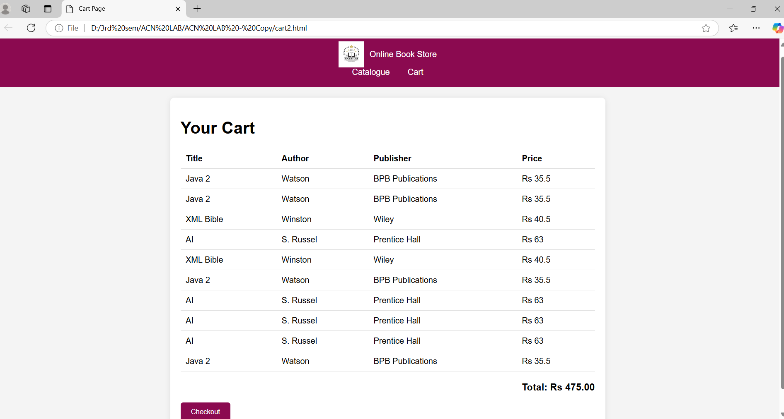

**ACN**

**1 .NETWORK TOPOLOGY**

* **STAR TOPOLOGY**

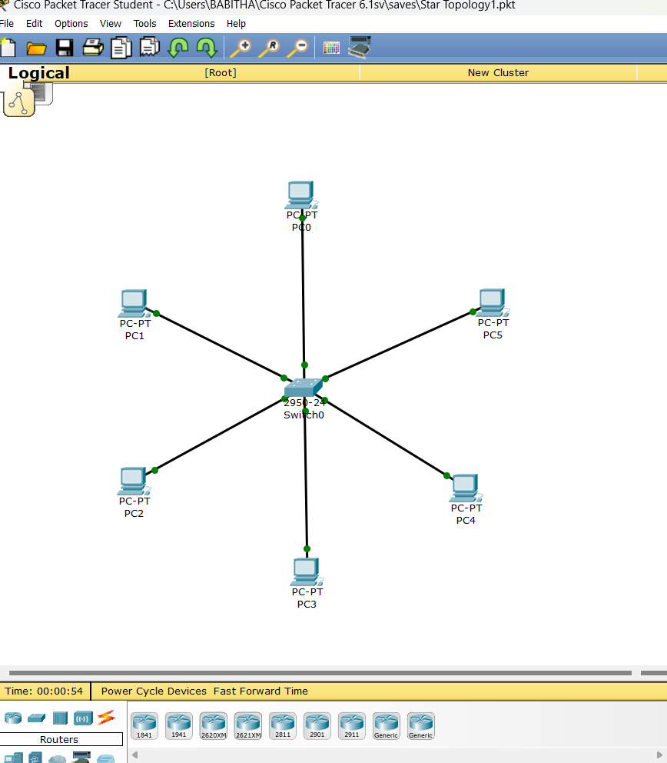

**BUS TOPOLOGY**

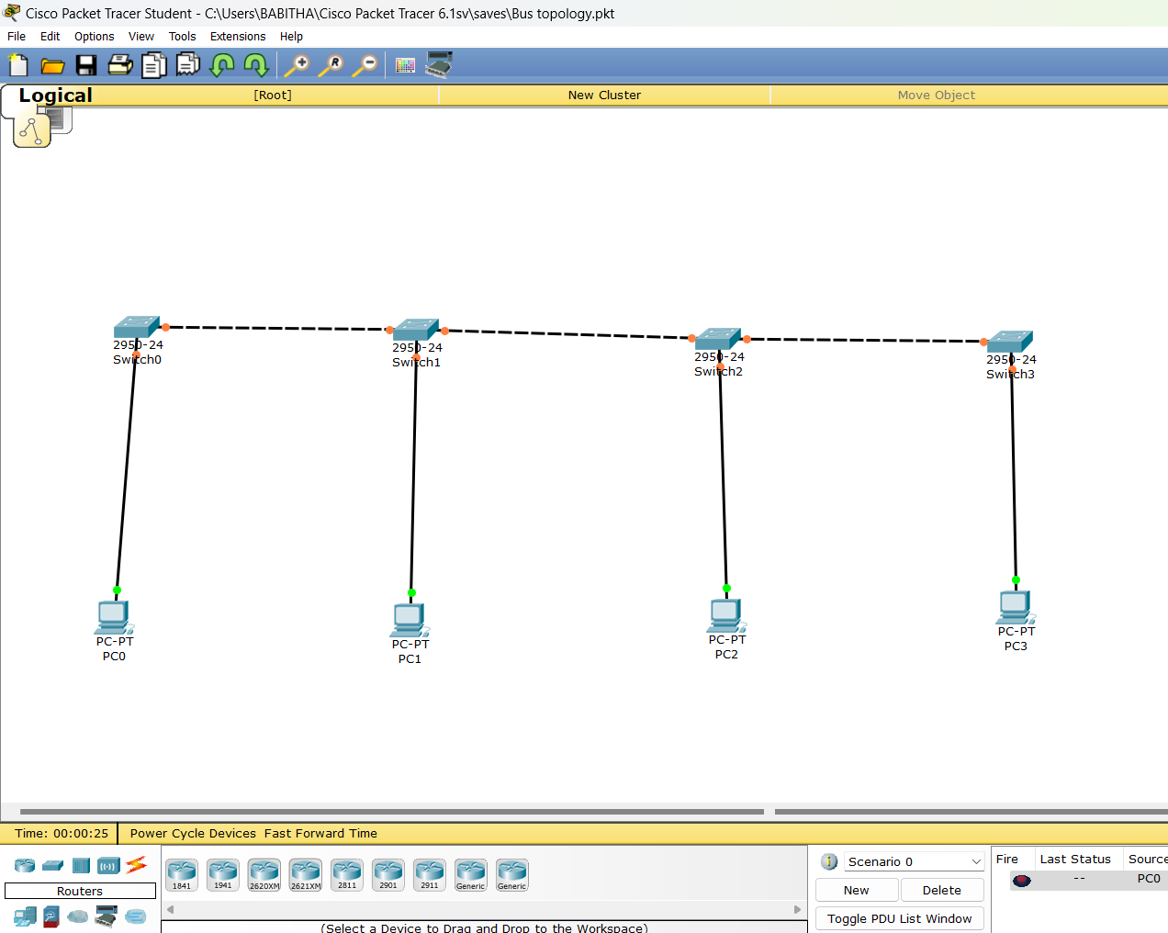

**2. VLAN**

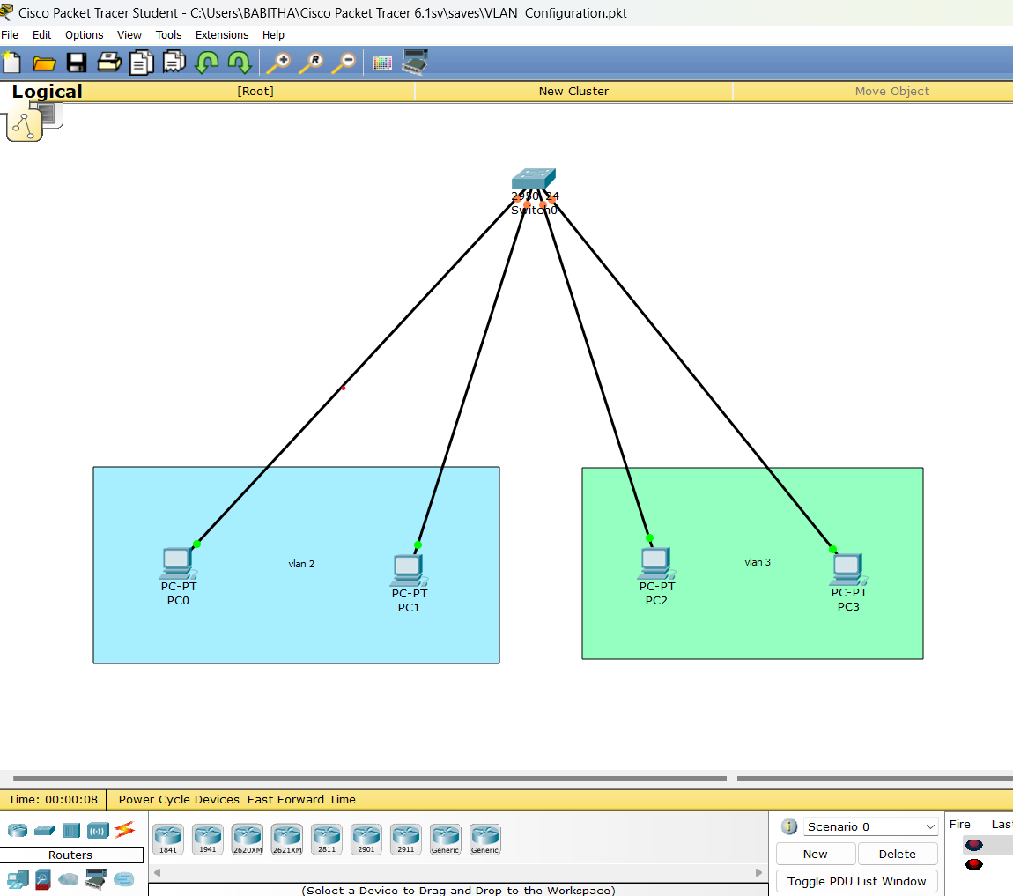

**3.FIREWALL**

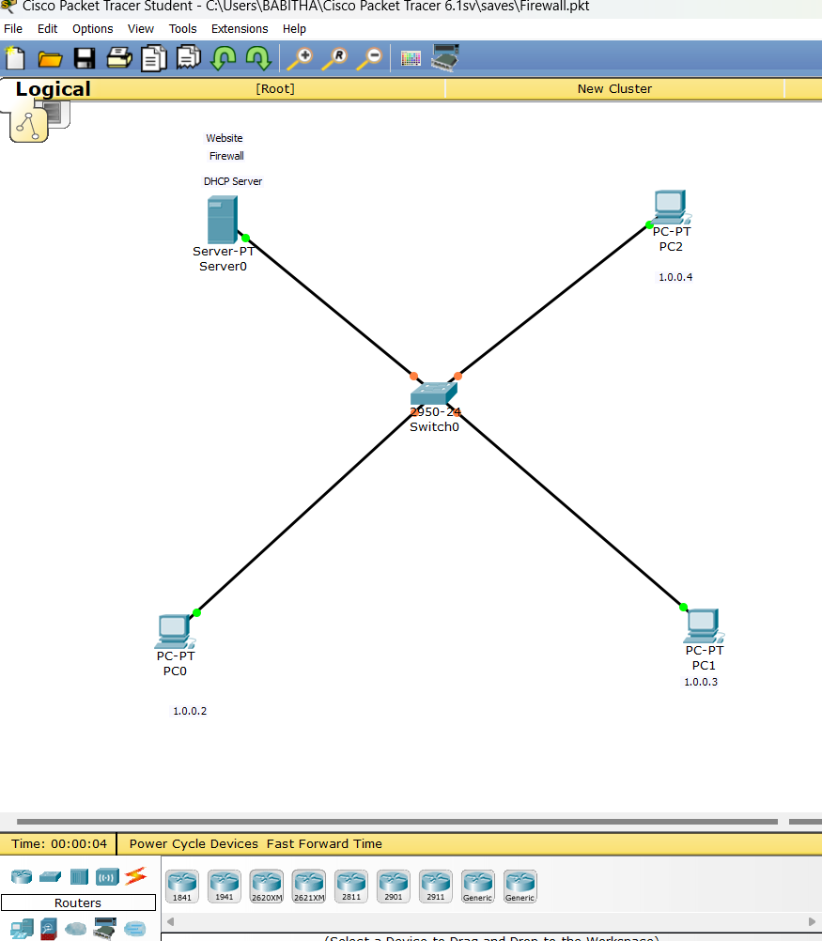

**4. ROUTERS CONFIGURATION**

